Development Log

# Version 1- 24/03/2025 – 30/03/2025

Today is my first day of developing the Rolsa Technology website so the main focus will be the front-end part of the website which will include the navbar, footer, outline pages, logo, titles and Database. With my version 1 I will not yet apply CSS I need to first make sure that there is a layout first and then add in the CSS in the second version since it is my first prototype. I was thinking to put the navbar at the top with all the information on the right hand side in a clear neat format.

This is what my navbar looks like in the first version

## Navbar

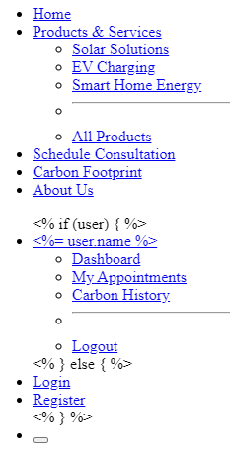

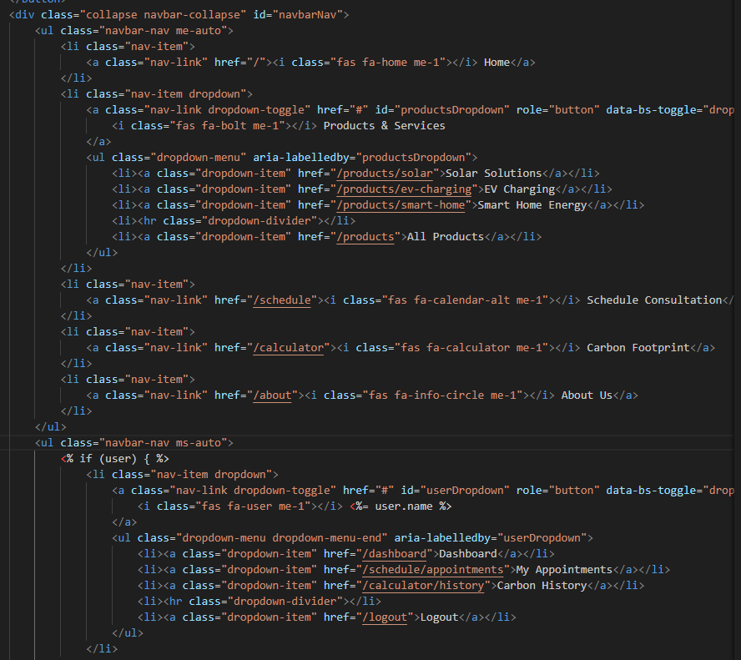

This code creates a responsive navigation bar for an energy services website using Bootstrap 5, featuring a dropdown menu for "Products & Services" (including Solar Solutions, EV Charging, and Smart Home Energy with a divider before All Products) alongside direct links to Schedule Consultation, Carbon Footprint Calculator, and About Us pages, all enhanced with Font Awesome icons for better visual recognition. The right side dynamically displays either a user dropdown menu (with Dashboard, Appointments, Carbon History, and Logout options) when logged in or Login/Register links for guests, using conditional rendering (<% if (user) %>) to personalise the interface based on authentication status. I implemented this structure to provide intuitive navigation that organises content hierarchically, improves user experience with clear visual cues, adapts seamlessly to different user states, maintains mobile responsiveness through Bootstrap's framework, and follows web development best practices for both functionality and maintainability while driving engagement through strategically placed calls-to-action.

This is what my Homepage looks like in Version 1

Home Page

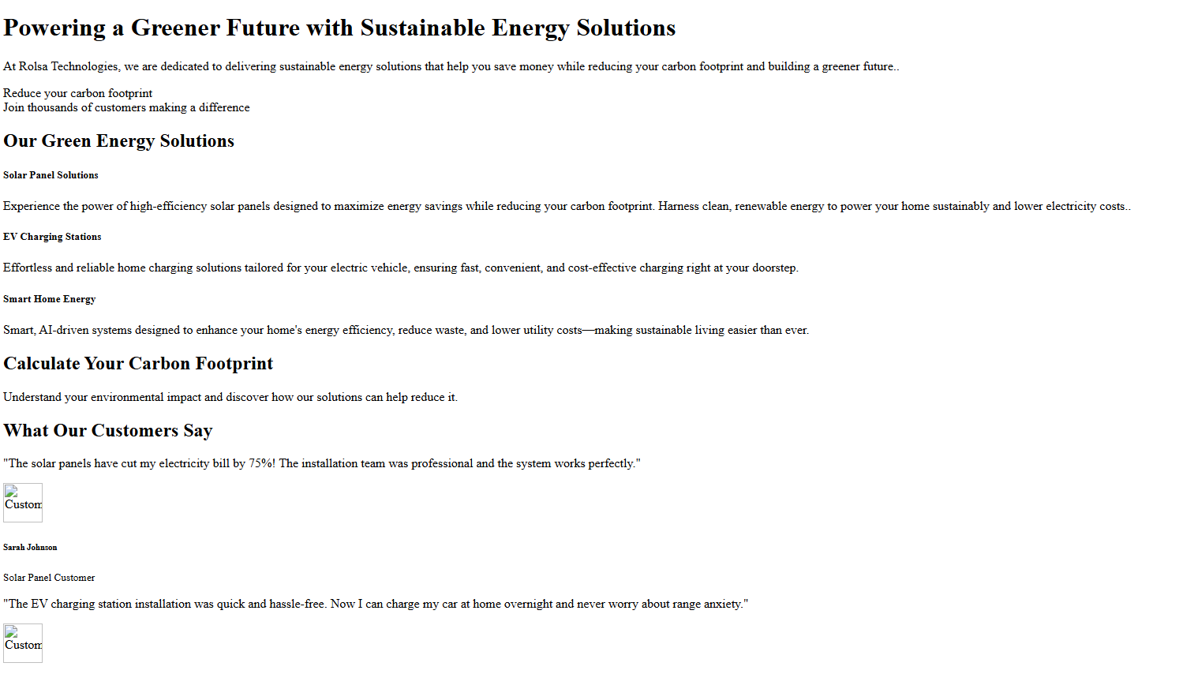

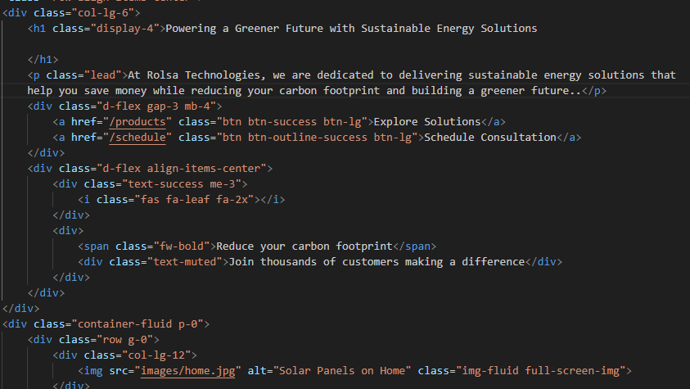

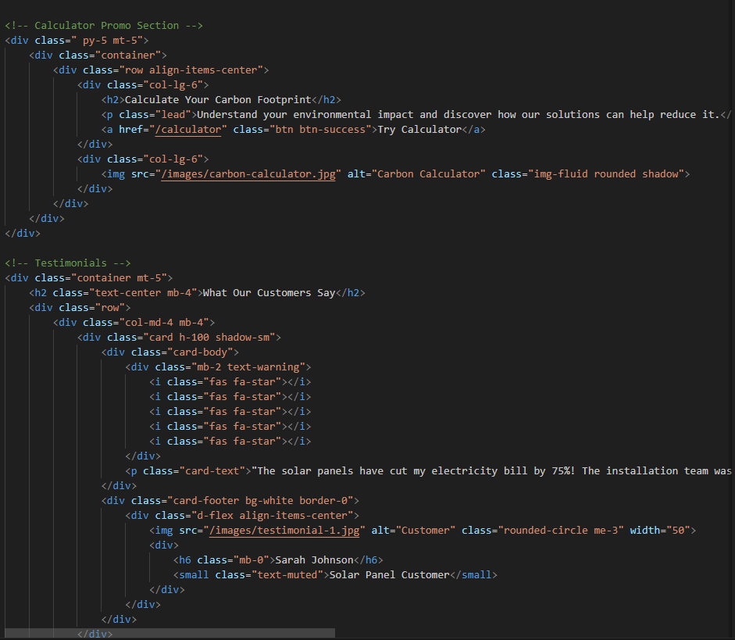

This code implements the core content sections for an energy solutions homepage, featuring a hero banner with a value proposition ("Powering a Greener Future"), followed by service cards (Solar, EV Charging, Smart Home), a carbon calculator promo, and customer testimonials—all structured with Bootstrap’s grid system for responsiveness. I included this to establish a clear information hierarchy: (1) The hero section immediately communicates Rolsa’s mission with primary CTAs, (2) the service cards visually categorise offerings with icons for quick scanning, (3) the calculator section drives engagement with an actionable tool, and (4) testimonials build social proof. The HTML-first approach (using Bootstrap’s default styling) ensures that there is content readability and functionality before Version 2/ Version 3 introduce any custom CSS, while the modular component structure (cards, flex layouts) allows for easy iterative testing of section ordering or messaging.

This is what my footer looks like in Version 1

## Footer

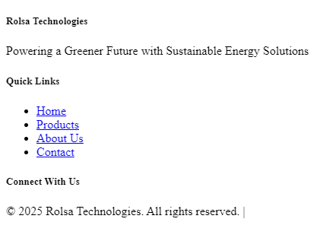

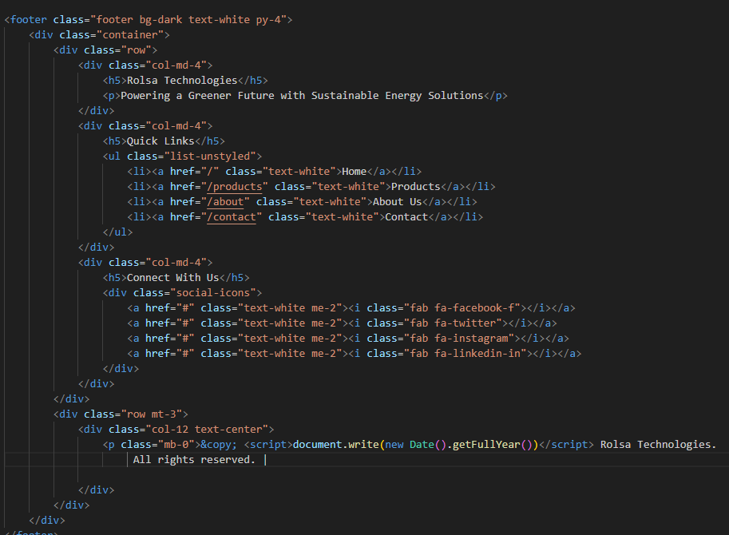

This footer section provides essential end-of-page navigation and company information, structured into three key columns: (1) Brand identity with Rolsa’s mission statement, (2) Quick Links for major site sections (Home, Products, About, Contact) using Bootstrap’s no style list for clean formatting, and (3) Social media links with Font Awesome icons for visual recognition. I implemented this to ensure consistent access to critical links across all pages to make it easier for the users to contact or if they want to go to other pages, also reinforces brand messaging, and encourages social engagement—all while maintaining mobile responsiveness through Bootstrap’s grid system. The dark background (bg-dark) with white text (text-white) ensures readability for the users whilst also aligning with common UX patterns for footers. This modular column structure allows easy future additions (e.g., newsletters, legal links) without layout disruption.

## About Page

This is what my about page looks like in Version 1

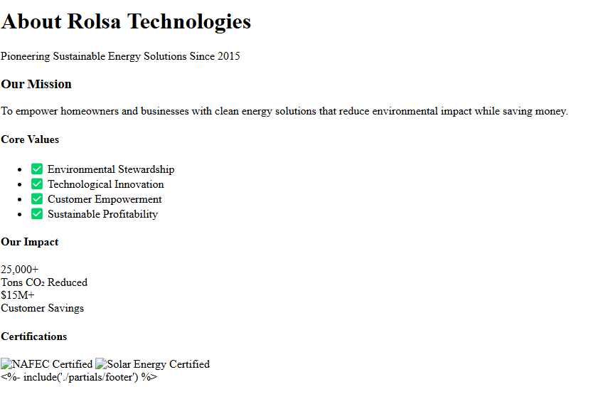

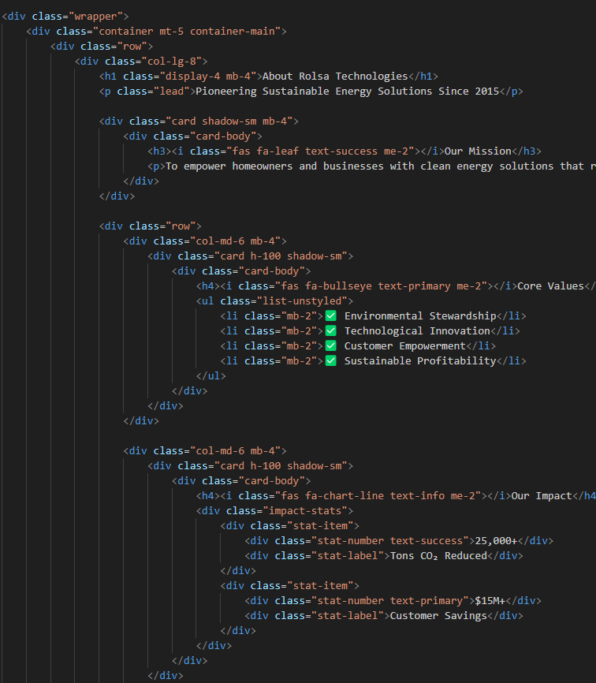

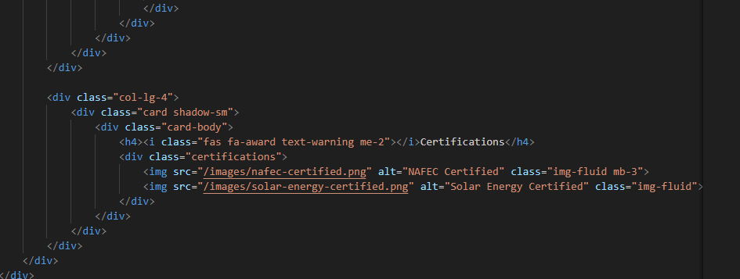

This About Us page effectively builds trust while communicating Rolsa's brand story through a clean, organised layout. It combines mission-driven content with visual credibility elements in three key sections: (1) a mission statement with eye-catching icons, (2) core values alongside quantifiable impact metrics, and (3) prominent industry certifications. The card-based Bootstrap design creates an accessible yet significant narrative that answers visitor questions immediately - who we are, what we stand for, and why we're credible - while the responsive grid ensures clarity across all devices. By showcasing achievements and values upfront, this page directly addresses the trust factor crucial for converting sustainability-conscious customers.

This is what my appointment page looks like in Version 1

## Appointment

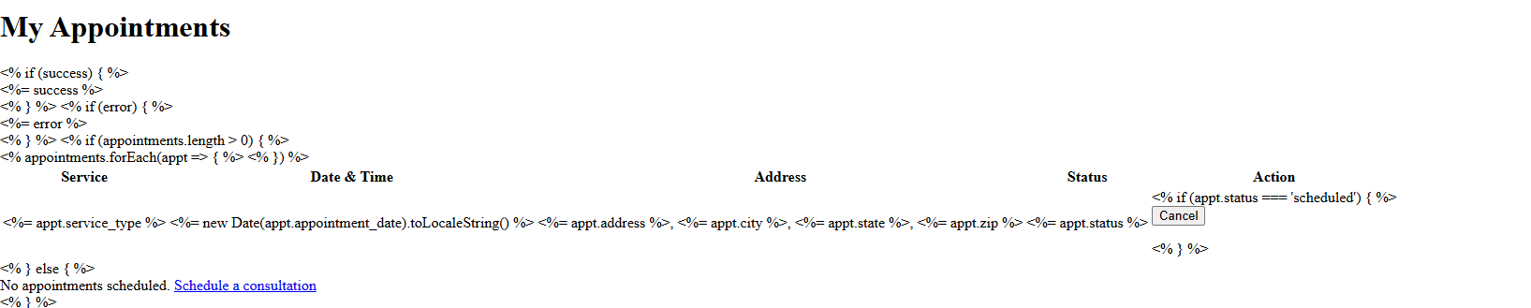

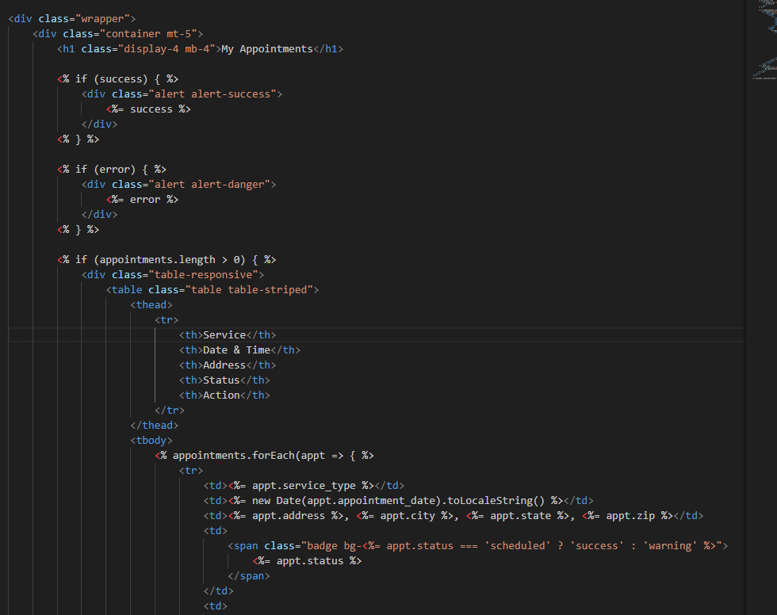

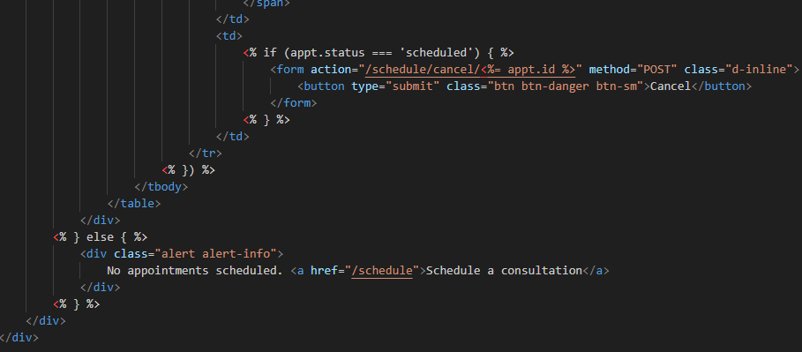

This appointments dashboard provides users with clear visibility and control over their scheduled services through a responsive table interface. The dynamic template first checks for success/error messages before displaying either: (1) A sortable table of upcoming appointments with status badges (color-coded for quick scanning) and cancel options for active bookings, or (2) A prompt to schedule new consultations when none exist. The design prioritises essential information - service type, datetime (formatted for readability), and location - while conditionally showing cancel actions only for 'scheduled' statuses, preventing invalid requests. Bootstrap's table styling ensures mobile responsiveness, and the badge system (success=green for active, warning=yellow for others) creates instant visual status recognition. This implementation balances user control with system integrity by handling cancellations via POST requests rather than client-side actions, while the empty state proactively drives conversions by linking directly to scheduling.

This is what my calculator page looks like in Version 1

## Calculator

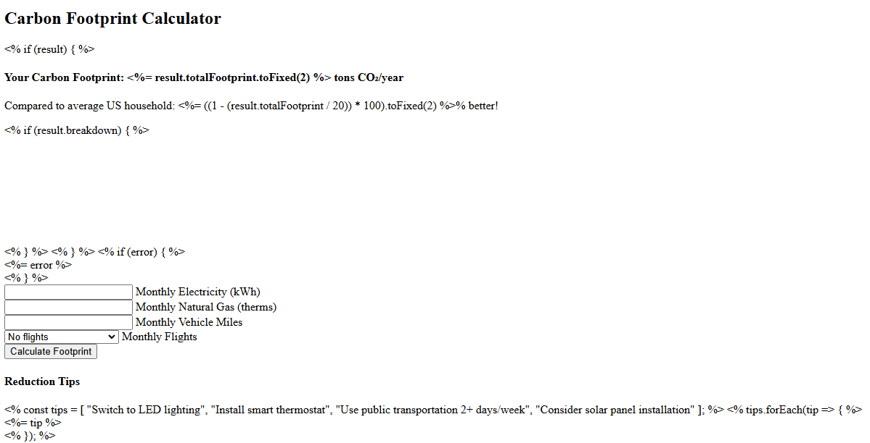

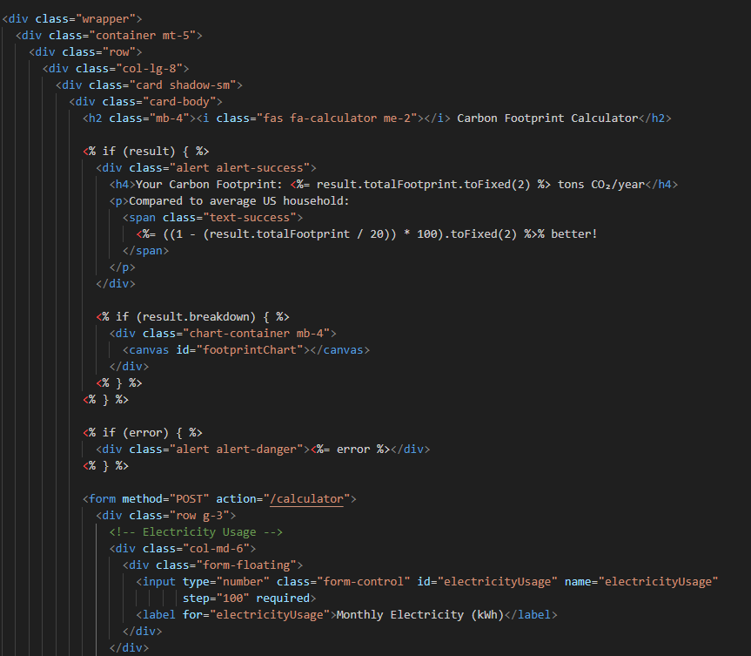

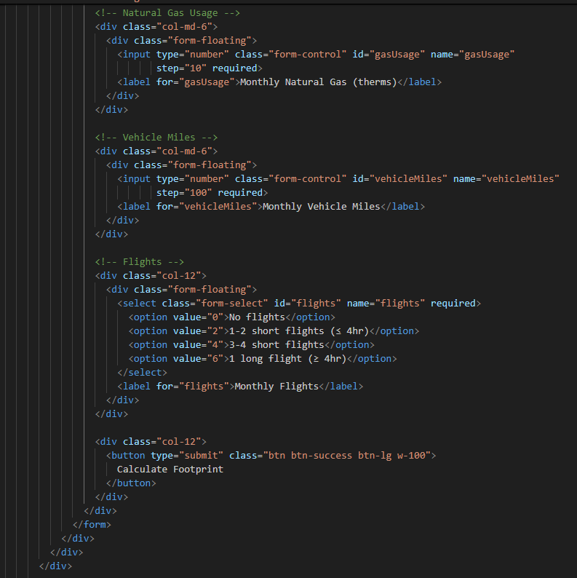

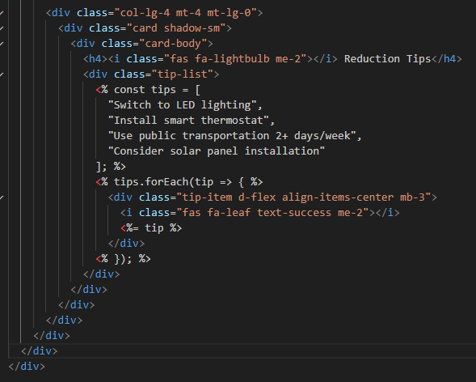

This interactive carbon footprint calculator provides users with personalised environmental impact assessment through a clean, two-column layout. The left column features a form collecting key consumption data (electricity, gas, transportation) with floating labels for optimal UX, which processes to display: (1) A prominent total CO₂ output comparison against national averages, (2) Visual data breakdown via Chart.js (conditionally rendered when results exist), and (3) Error handling for invalid inputs. The right sidebar offers immediately actionable reduction tips with iconography for quick scanning. The design achieves three goals simultaneously: education (through comparative metrics), engagement (via instant visual feedback), and conversion (by suggesting Rolsa's solar solutions among the tips). Bootstrap's responsive grid ensures the calculator remains usable on all devices while maintaining the tips sidebar's visibility.

This is what my schedule consultation page looks like in Version 1

## Schedule Consultation

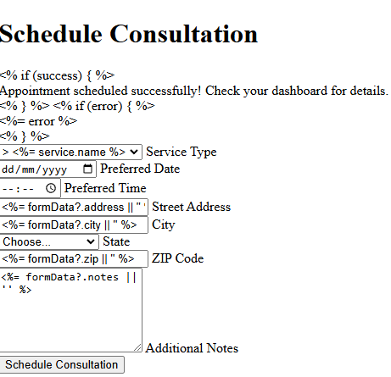

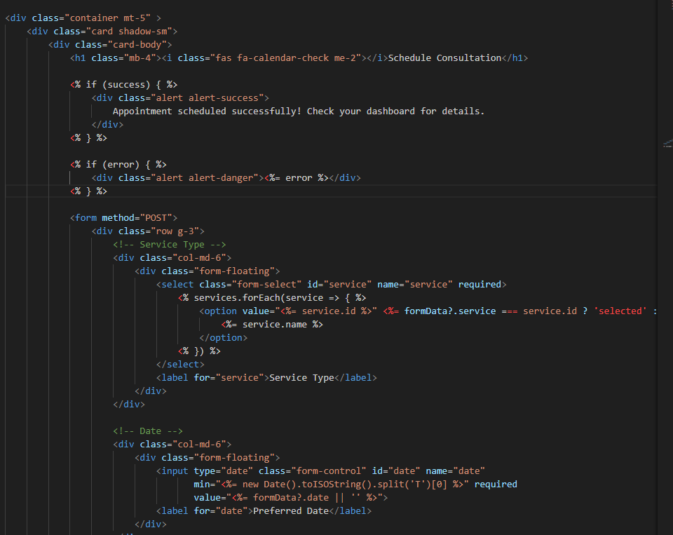

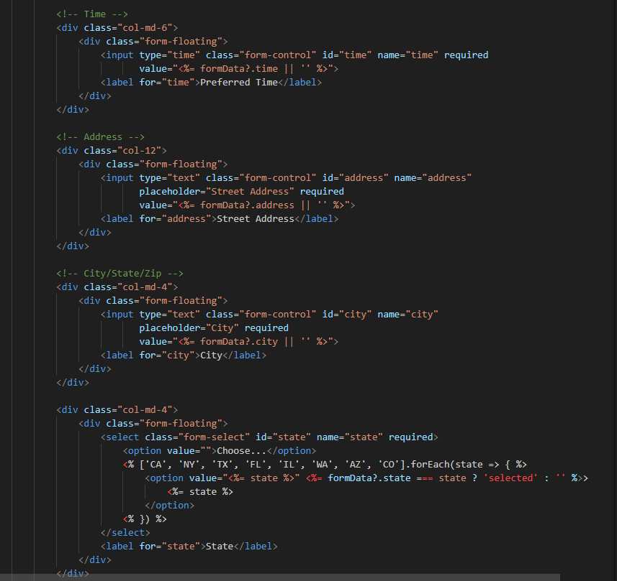

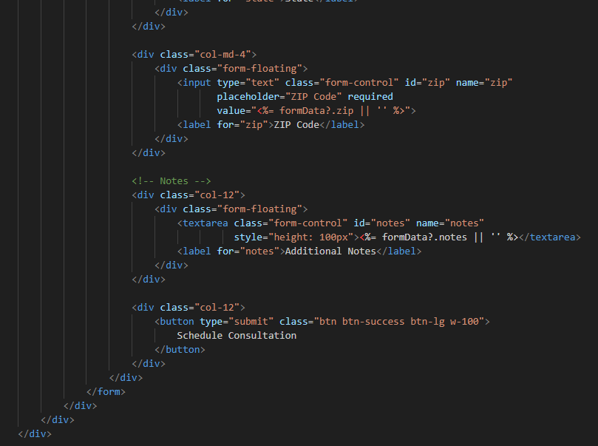

This consultation scheduling form provides users with a seamless and intuitive booking experience by organising information logically and minimising friction. The clean, responsive design adapts to any device while maintaining usability, with floating labels that keep form fields clear and date pickers that prevent scheduling errors by restricting past dates. Users benefit from smart features like auto-populated service options and saved form data if corrections are needed, reducing frustration. The visual feedback through success/error messages keeps users informed, while the straightforward address collection and notes field accommodate different needs. By combining these thoughtful design elements with a prominent call-to-action button, the form makes scheduling consultations quick and effortless, ultimately improving conversion rates while delivering a positive user experience that reflects well on your brand's professionalism.

The technical implementation ensures reliability with client-side validation for immediate feedback and server-side data handling for security, while the accessible layout works for all users. This balance of user-friendly design and robust functionality creates a trustworthy first touchpoint that sets the stage for quality service interactions.

This is what my Products page looks like in Version 1

## Products

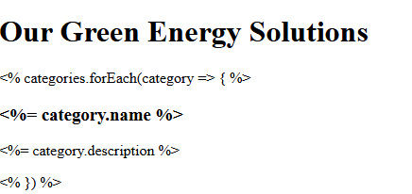

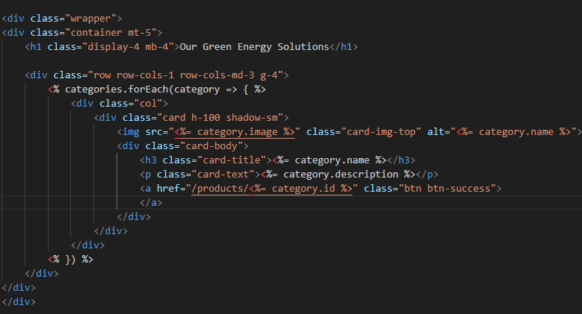

This products page effectively showcases the green energy solutions in a user-friendly grid layout which helps customers quickly browse and compare options. The clean card-based design presents each category with a visual (image), clear title, and concise description - giving visitors just enough information to identify what interests them without overwhelming them. The responsive grid automatically adjusts from 1 column on mobile to 3 columns on desktop, ensuring optimal viewing on all devices while maintaining visual consistency through shadow effects and equal card heights. Each card links to more detailed product pages, creating a natural browsing flow that guides users from discovery to conversion. The simple yet attractive presentation focuses attention on the solutions' benefits while making it easy for customers to find what they need, whether they're researching options or ready to take the next step toward sustainable energy.

This is what my Register page looks like in Version 1

## Register

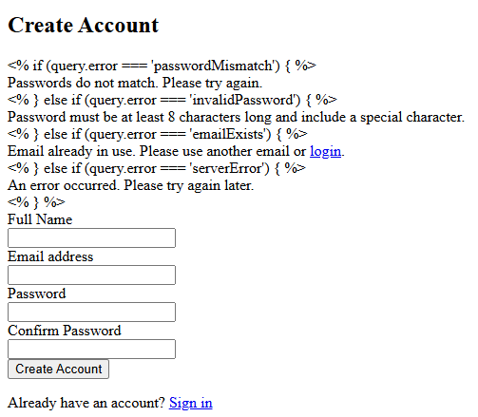

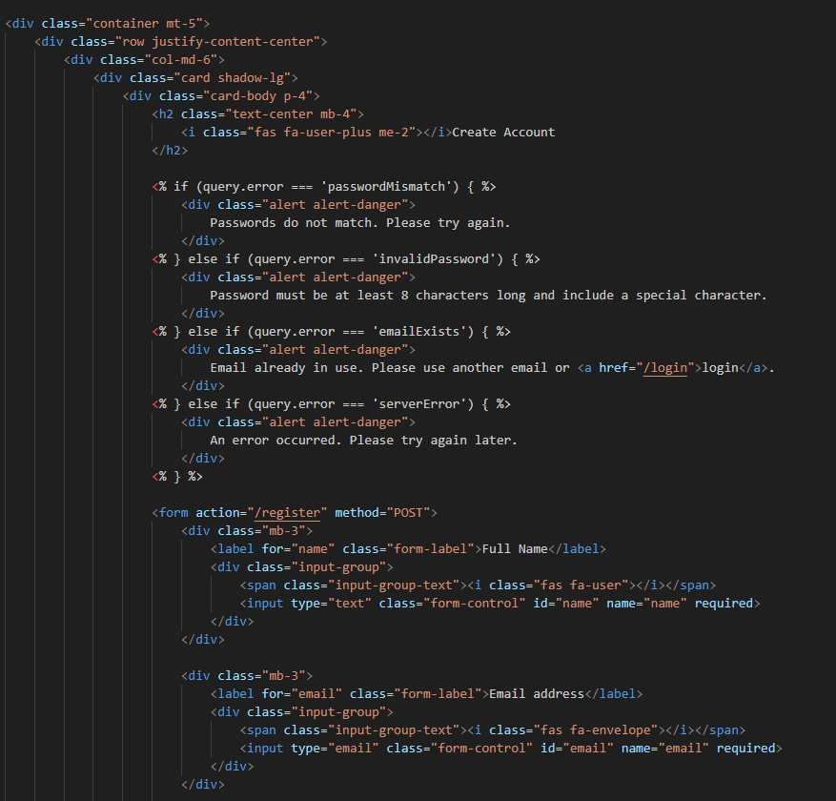

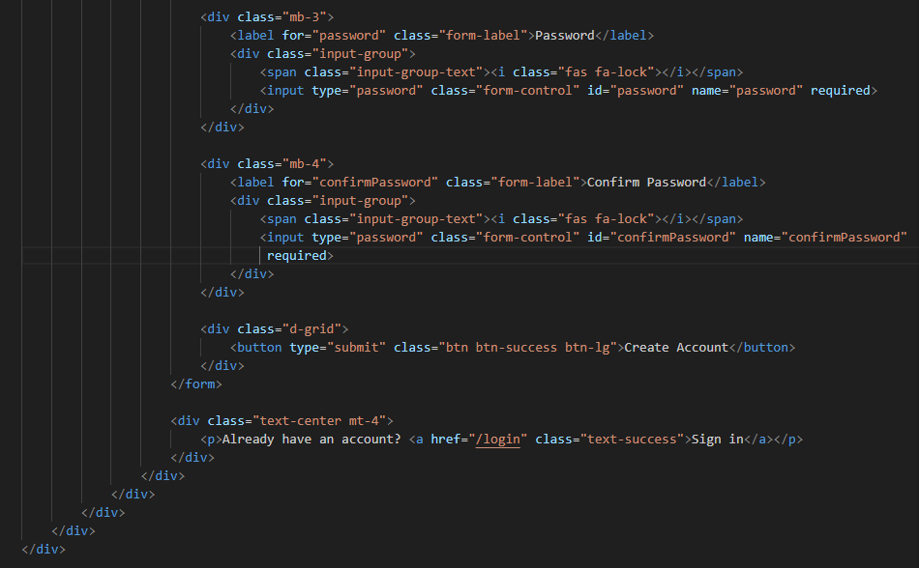

This registration form provides a streamlined and secure account creation experience that prioritises user convenience while maintaining robust data protection. The clean, centred layout focuses attention on essential fields with visual icons that enhance usability, while implementing multiple security layers: client-side validation (required fields) combines with server-side checks for password complexity (8+ chars with special characters), email uniqueness, and password matching to prevent compromised credentials. The form handles errors clearly - explaining validation rules without revealing system details - while password fields mask input and require confirmation to prevent typos. Security extends to the submission process (POST method encryption) and session management (error handling that doesn't expose database info), all presented in a mobile-responsive design that maintains protection across devices. The result is a frictionless yet secure gateway that builds trust through visible safeguards (lock icons, immediate feedback) while operating discreet protections behind the scenes.

This is what my Log-In page looks like in Version 1

## Log-In

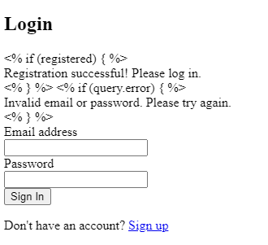

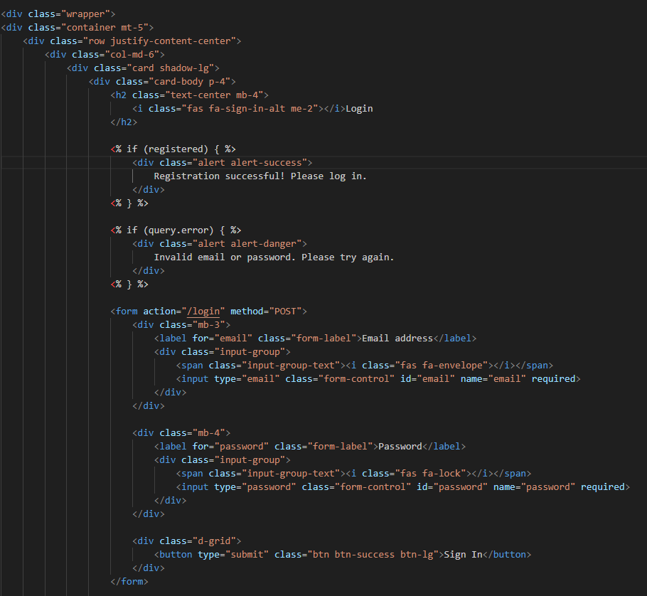

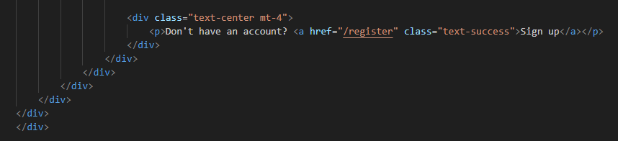

This login page offers users a secure and intuitive authentication experience with a clean, focused design that prioritises both security and usability. The centred card layout minimises distractions while clearly presenting the login form with visual cues (envelope and lock icons) that guide users through the process. Security is implemented through multiple layers: password masking, required field validation, and POST method submission encrypts credentials during transmission. The system provides clear but guarded error messaging ("Invalid email or password") that protects against brute force attacks by not revealing which field failed validation. A success notification appears after registration to smoothly transition users to login, while the responsive design ensures equal security on all devices. The layout maintains conversion pathways with prominent sign-in buttons and easy access to registration, creating a balanced solution that safeguards accounts while minimising login friction.

This is what my Database looks like in Version 1

## Database

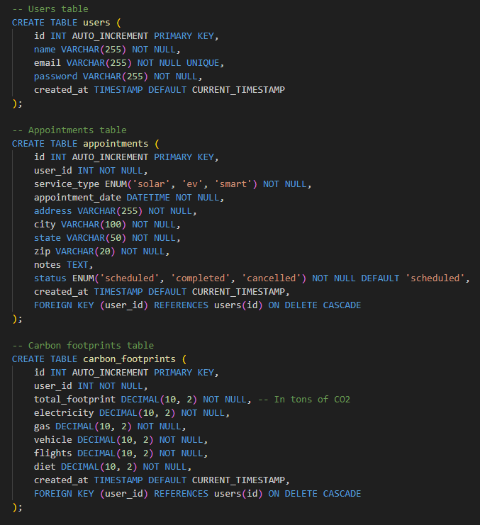

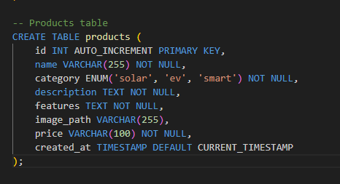

This SQL schema defines a relational database structure for a green energy application with four core tables: (1) The **users** table stores customer account information with basic authentication fields and timestamps; (2) The appointments table tracks service bookings with location details, service type restrictions (solar/EV/smart), and status tracking, linked to users via foreign key with cascade deletion; (3) The carbon footprints table records environmental impact metrics in tons of CO2 across multiple categories (electricity, gas, etc.), also user-linked; and (4) The **products** table catalogues available solutions with categorised offerings (ENUM constrained to solar/EV/smart), detailed descriptions, and pricing. The schema enforces data integrity through primary/foreign keys, NOT NULL constraints, and ENUM type validations while automatically tracking record creation times via DEFAULT CURRENT_TIMESTAMP. The appointments and carbon data both reference users through foreign keys with ON DELETE CASCADE to maintain referential integrity when accounts are removed. This normalised structure supports core application functionality while allowing for future expansion.

# Version 2- 1/04/2025 – 5/04/2025

Today is my first day of developing the second version of Rolsa Technology website so the main focus will be the back-end part of the website which will include the navbar, footer, outline pages, logo, titles and Database. With my version 2 I will be applying CSS and JavaScript I need to first make sure

This is what my navbar looks like in the second version

## Navbar



The navbar boasts a clean, modern design with a green colour scheme that reflects Rolsa Technology’s commitment to sustainability. On the left, the company logo and name reinforce brand identity, while the centre features five key navigation links—including dropdown menus for "Products" and "Services" to streamline user access. To the right, a user-friendly login/register section ensures quick account management, and a moon icon enables a dark mode toggle, enhancing accessibility for users with light sensitivity or visual impairments. This thoughtful layout balances aesthetics, functionality, and inclusivity, delivering a seamless experience for all visitors.



I added this line of code in to make the navbar colour green where it says bg-success this is what makes it green due to me using bootstrap

This is what my Homepage looks like in the second version

## Homepage

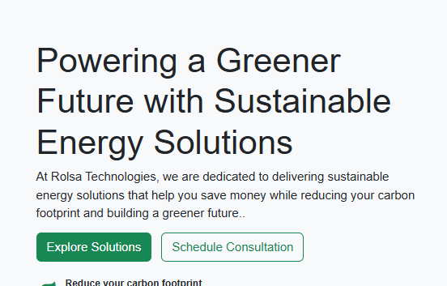

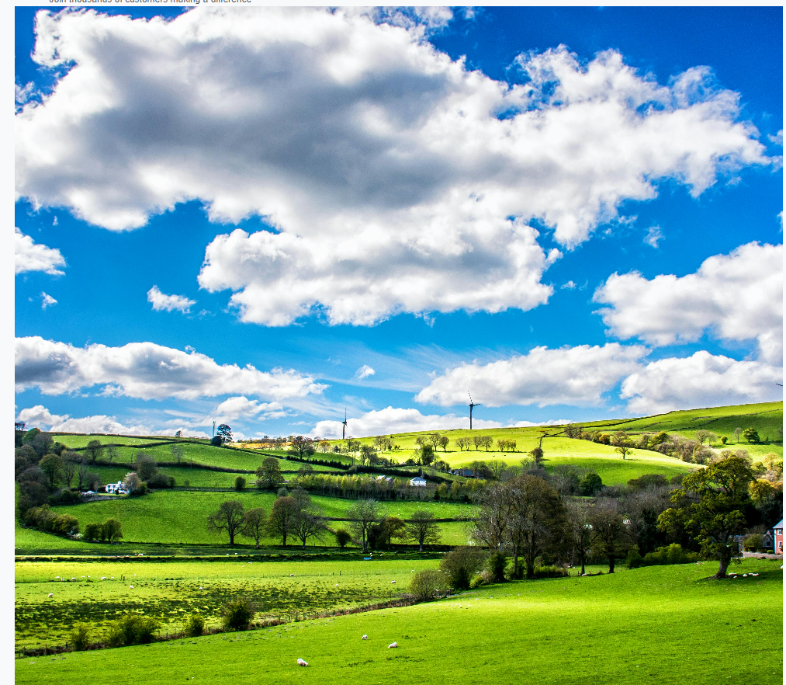

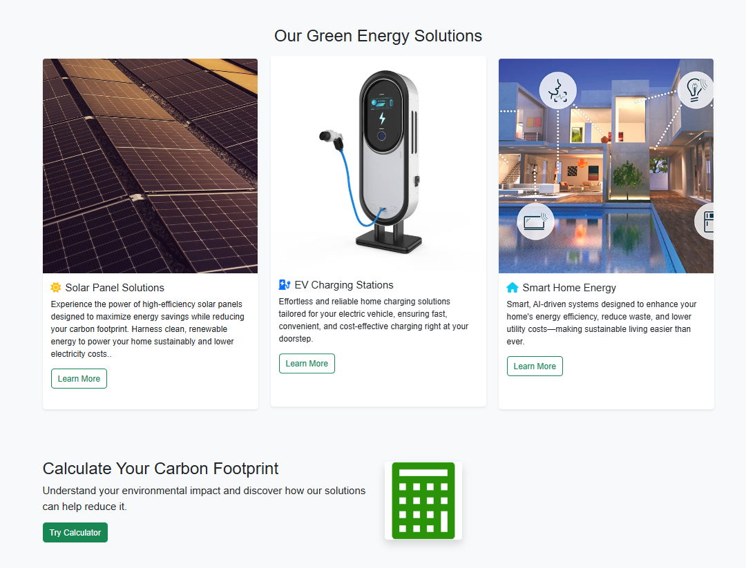

I had applied CSS to have it like this layout where everything is clear and concise. Allows the users to explore solutions and schedule consultations as well as look at the products that Rolsa technology are selling as well as the reviews they have left promoting the product and company.

I have added something in that was not in the first version which is a stats counter that counts the customers served solar power installed, and EV Chargers installed.



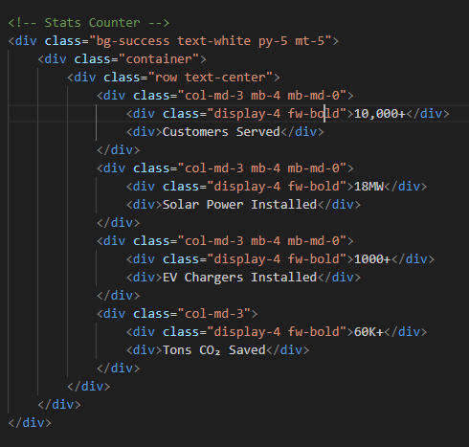

This is what my footer looks like in the second version

## Footer



I have made the footer black since it would stand out more for the user and ne WCAG compliant. I have added in the links such as Facebook twitter Instagram and linked in so that the user can follow Rolsa technology on those platforms. I have added that in this version 2 since it wasn’t in version 1



Colour Scheme

Links

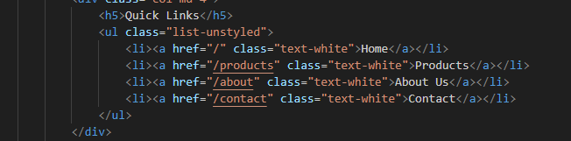

This is what my about page looks like in Version 2

## About Page

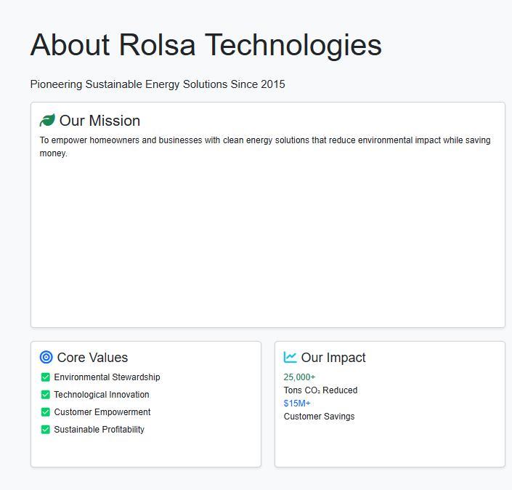

The redesigned About Page for Rolsa Technologies now delivers a narrative that combines brand identity with social proof through CSS styling and content organisation. The page prominently showcases the core values—sustainability, innovation, and customer commitment—using clean typography and white space to ensure readability. The responsive CSS implementation guarantees seamless viewing across devices, with careful attention to contrast ratios and font sising for accessibility. 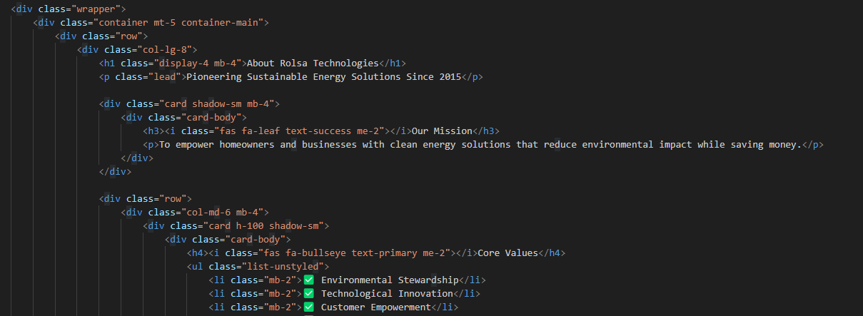

This is what my Appointment Page looks like in Version 2

## Appointment Page

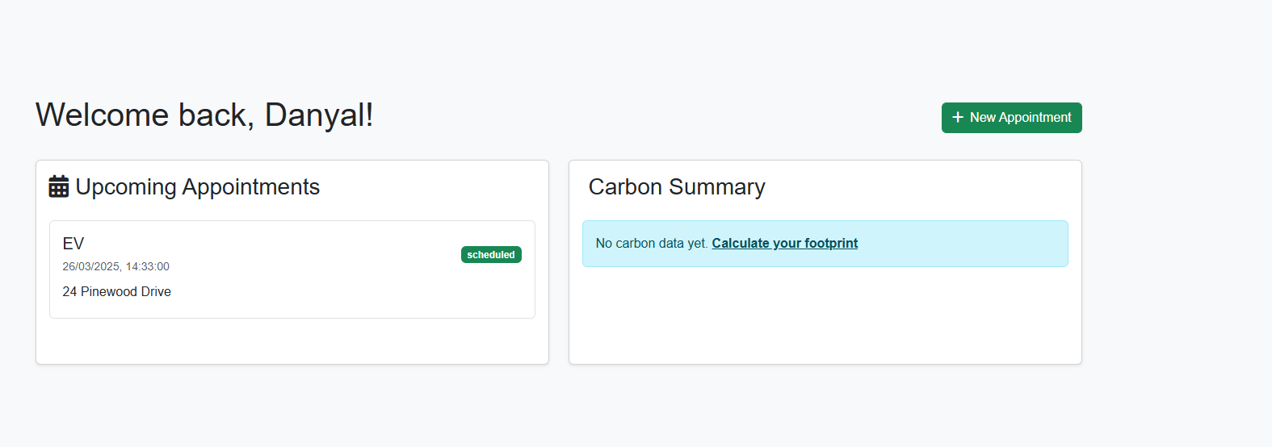

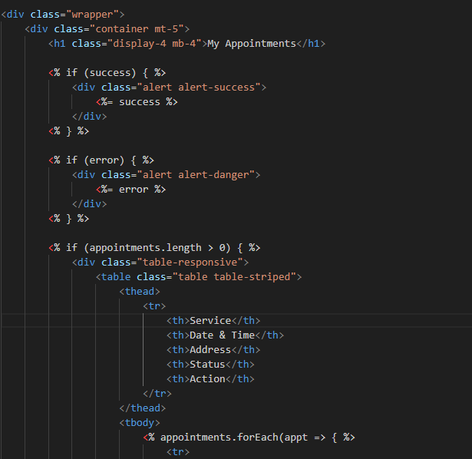

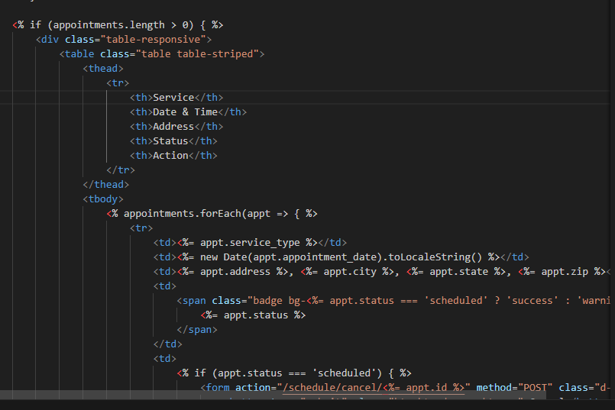

When a user books an appointment, it will be displayed under "Upcoming Appointments" for easy tracking. Additionally, a "New Appointment" button is conveniently placed at the top right corner, allowing users to quickly schedule another visit without unnecessary navigation. This streamlined design enhances user experience by keeping important functions accessible and appointments clearly visible.

This is what my Schedule Consultation page looks like in Version 2

## Schedule Consultation

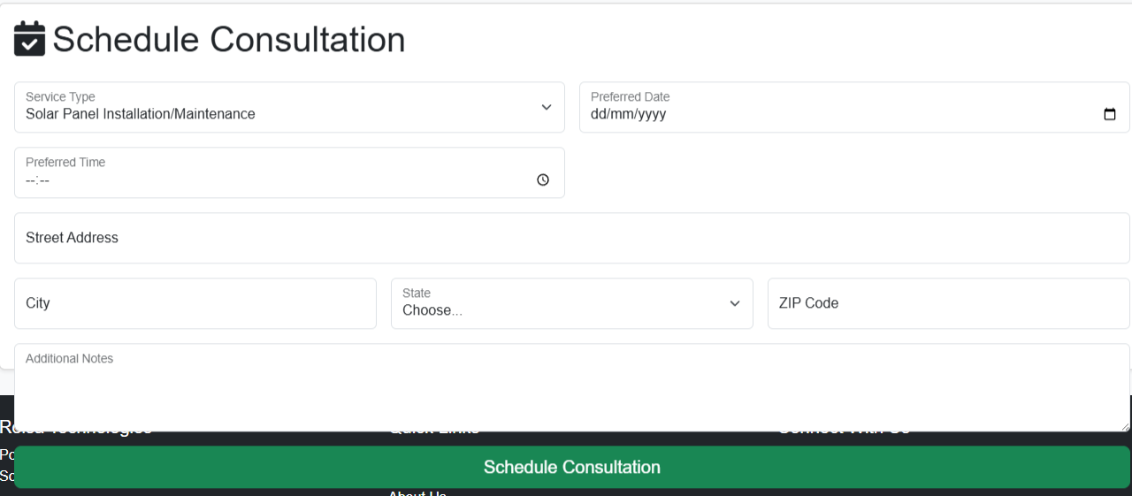

The Schedule Consultation page allows users to select their preferred service type, appointment date, and location details—including street address, city, state, and SIP code. By collecting this information upfront, we ensure a seamless and personalised experience tailored to their needs. All data provided is used solely to enhance their service, making the process efficient and user focused. This not only simplifies scheduling but also ensures accuracy and convenience for every appointment.

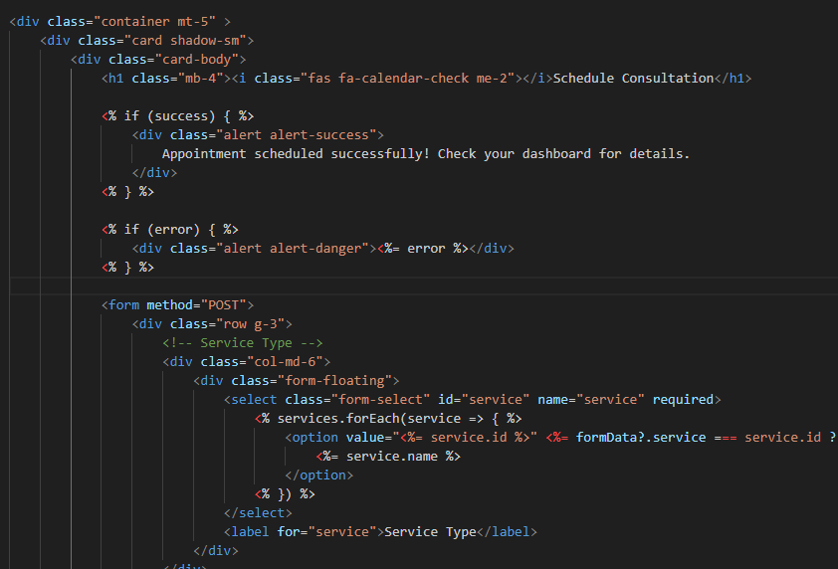

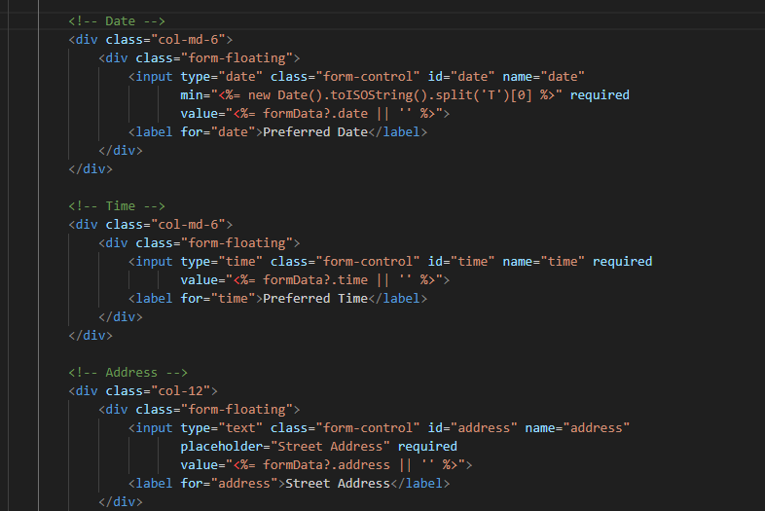

This is what my Carbon Calculator page looks like in Version 2

## Carbon Calculator

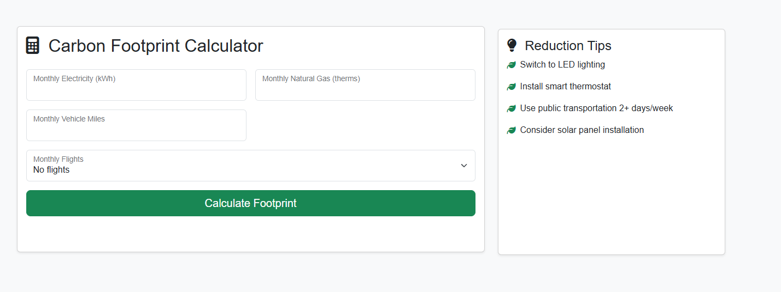

The platform enables users to input key environmental data—including monthly electricity usage, natural gas consumption, and vehicle miles travelled—along with personalised reduction tips. With this information, they can accurately calculate their carbon footprint, providing valuable insights into their environmental impact. This feature is both essential and impactful, empowering users to make informed, sustainable choices while tracking their progress toward reducing emissions. By offering these tools, we support eco-conscious decisions that benefit both individuals and the planet.

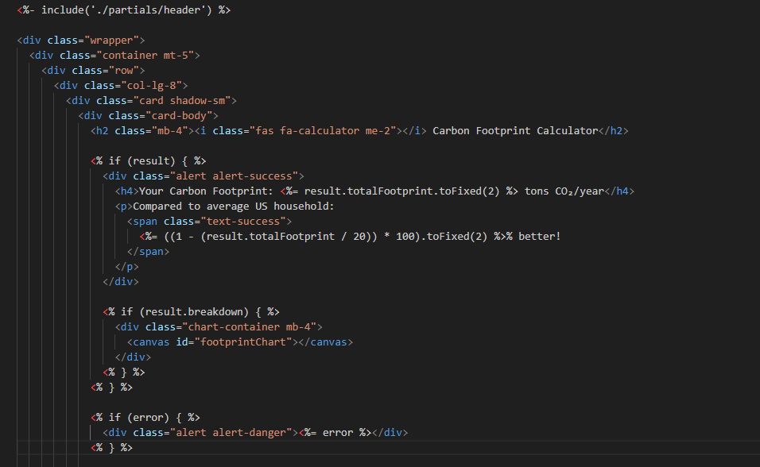

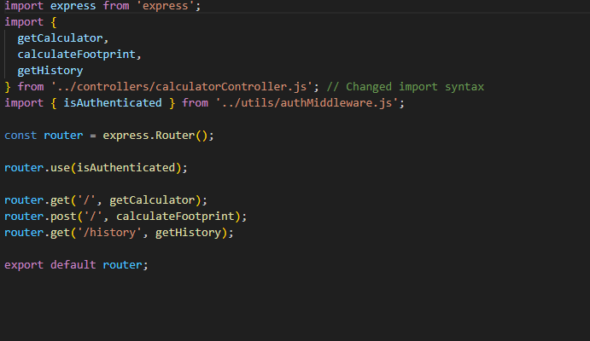

This is what my Products page looks like in Version 2

## Products

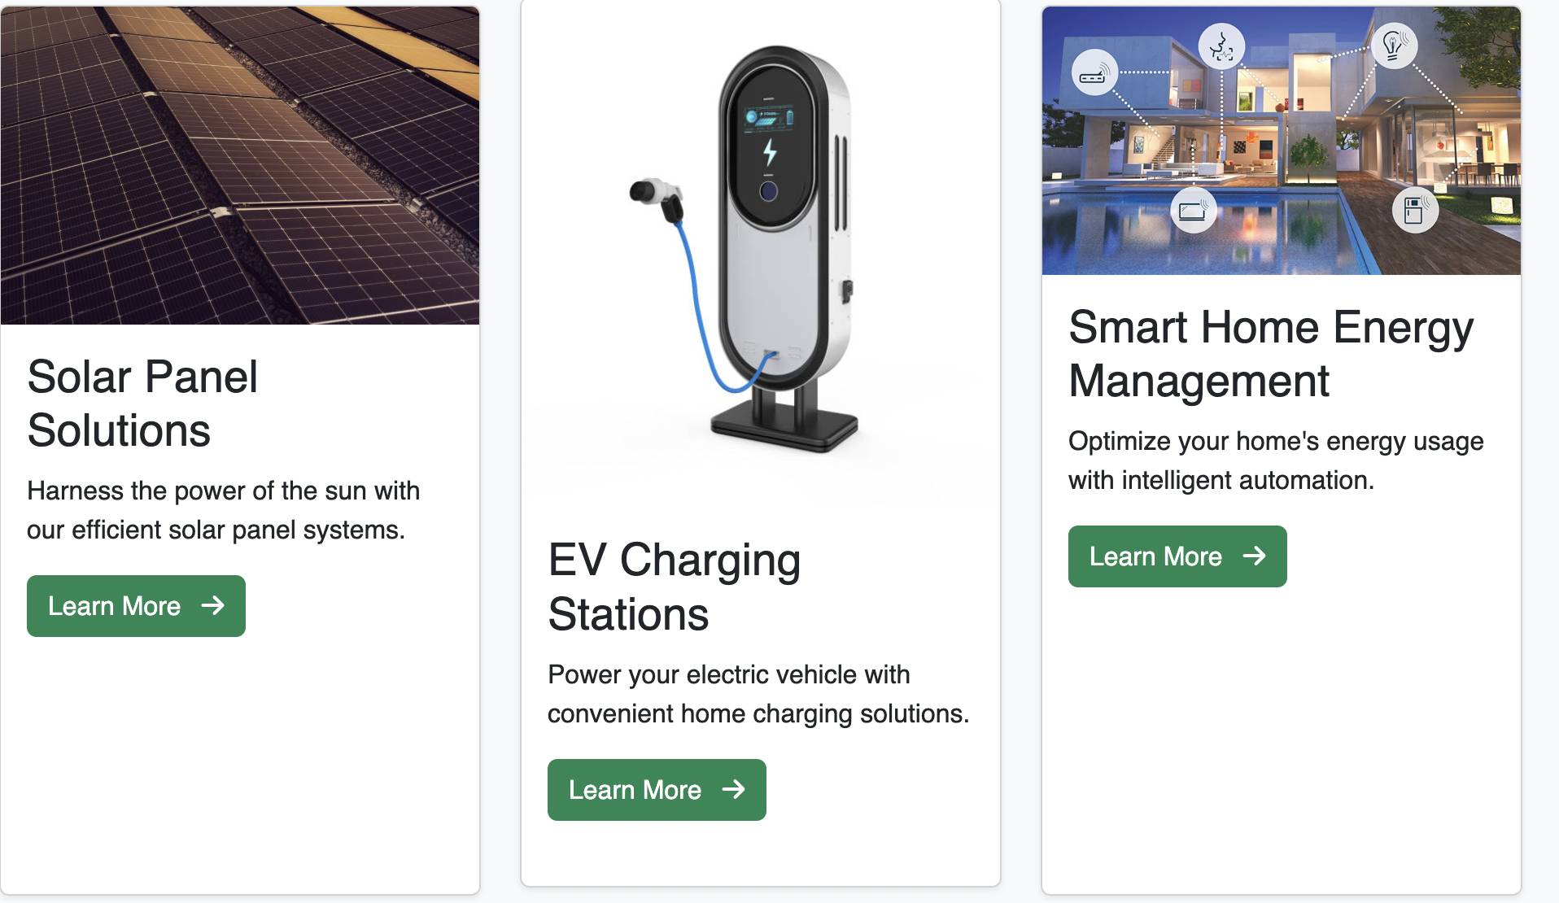

The products page showcases Rolsa Technology's comprehensive range of innovative sustainable energy solutions. Each product features detailed imagery with interactive 'Learn More' buttons, enabling customers to easily access in-depth specifications, environmental benefits, and cost-saving advantages. This curated experience empowers clients to make informed decisions about our solar energy systems, EV charging stations, and smart home technologies, while highlighting how each solution contributes to both ecological preservation and long-term economic efficiency."

This is what my Solar Panel Solutions page looks like in Version 2

## Solar Panel Solutions

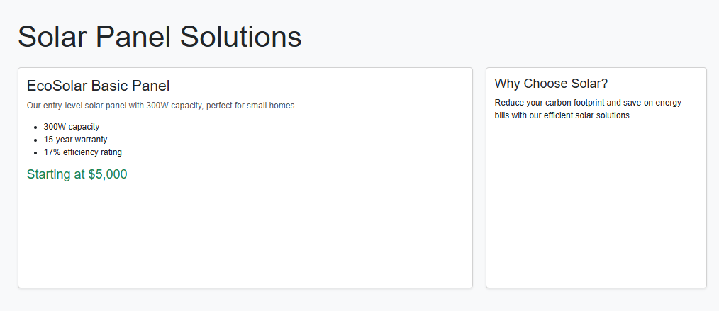

For my version 2 which was not in version 1. I developed a page for Solar Panel Solutions which clearly articulates the value of Rolsa’s solar technology, providing customers with a comprehensive yet accessible breakdown of the system’s functionality, benefits, and cost structure. By detailing how the panels convert sunlight into energy, the page educates users on the technology while emphasising tangible advantages—from reduced electricity bills and energy independence to environmental sustainability. Transparent pricing information empowers customers to evaluate the investment, and the inclusion of technical requirements (such as roof specifications or installation conditions) ensures visitors can quickly assess compatibility with their homes. This customer-centric approach not only informs but persuades, positioning Rolsa as a trusted advisor in renewable energy solutions by addressing both practical considerations and long-term benefits in a single, cohesive presentation.

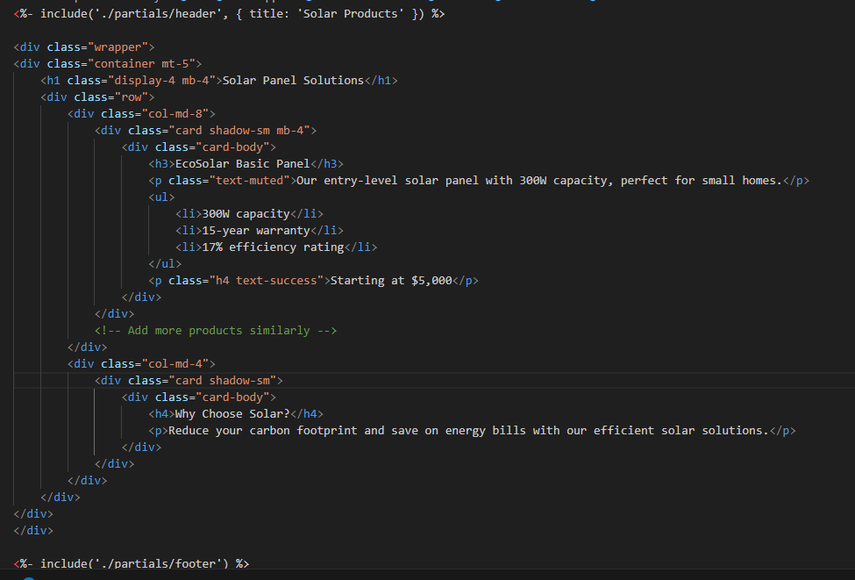

This is what my Smart Home Energy Management page looks like in Version 2

## Smart Home Energy Management

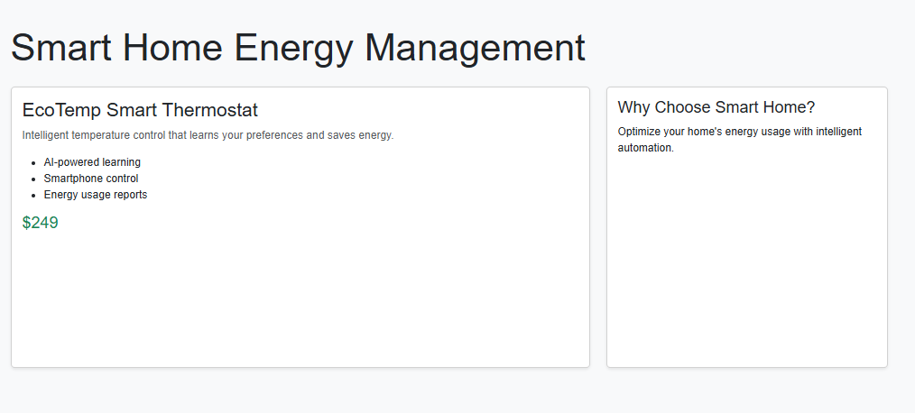

For my version 2 which was not in version 1. I developed a page for Smart Home Energy Management which provides customers with a comprehensive overview of this innovative solution, clearly explaining how the system works and its tangible benefits. By detailing the product's energy-saving capabilities, cost efficiency, and environmental impact, the page effectively communicates the value proposition to potential buyers. The content strategically addresses customer pain points, demonstrating how automated energy optimisation can reduce utility bills while contributing to sustainable living. Pricing transparency has been incorporated to help users make informed purchasing decisions, completing a persuasive yet informative product presentation that bridges the gap between technical features and real-world advantages. This addition to your product lineup not only expands Rolsa's offerings but also strengthens your position as a provider of comprehensive, customer-centric energy solutions.

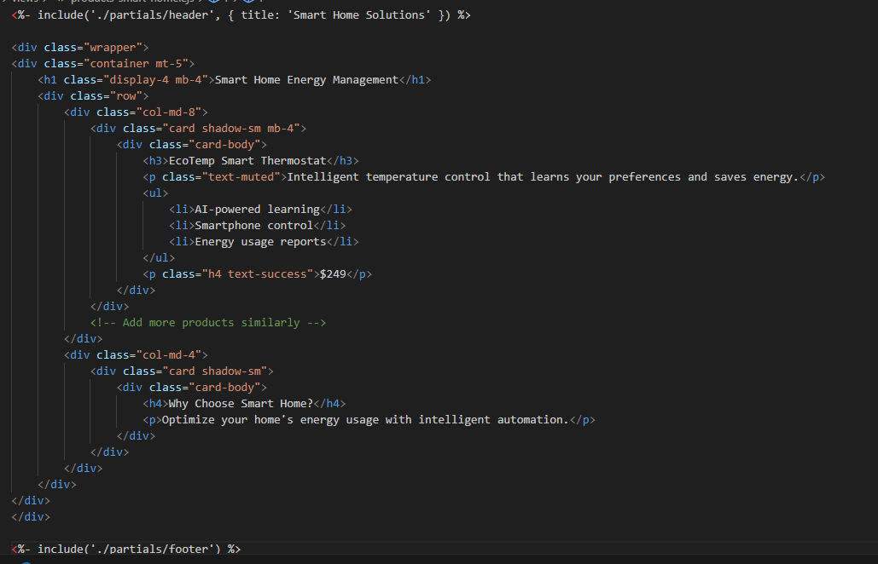

This is what my EV Charging Station page looks like in Version 2

## EV Charging Station

This is what Register looks like in Version 2

## Register

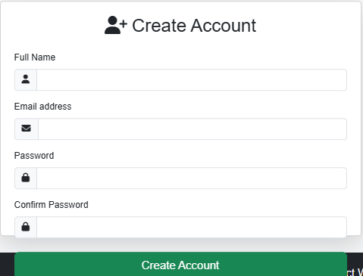

The redesigned registration page now features a clean, intuitive form with clear visual cues and improved functionality. Using strategic CSS styling, the form collects essential user details - full name, email, password, and confirmation - with responsive input fields that provide real-time validation feedback. Font Awesome icons (like the envelope for email and lock for passwords) have been incorporated beside each field to guide users visually, while subtle symbols (such as eye toggles for password visibility) enhance usability. Thoughtful spacing, contrasting colours, and error-state styling ensure accessibility compliance while maintaining Rolsa's green branding. The minimalist layout reduces cognitive load, focusing users on the conversion goal while inline validation helps prevent submission errors.

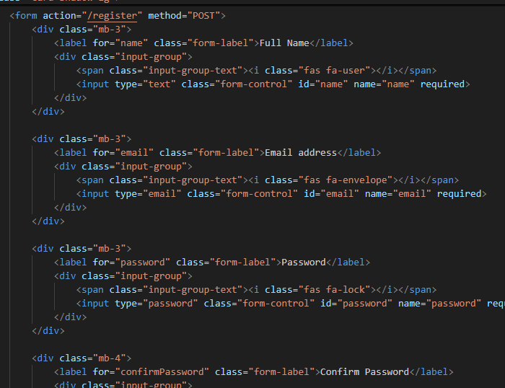

This is what Log-in looks like in Version 2

## Log-In

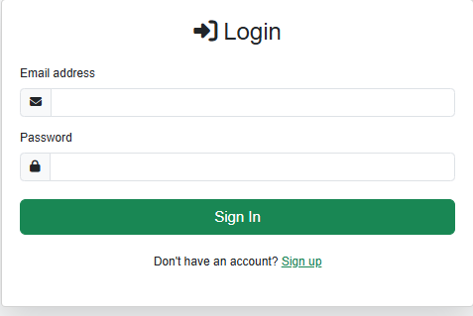

The login interface has been thoughtfully designed for clarity and ease of use, featuring clean CSS styling that presents email and password fields with intuitive visual hierarchy. Input fields are prominently displayed with ample spacing and subtle border treatments to guide user focus, while maintaining Rolsa's brand-consistent colour scheme. A responsive design ensures the form remains accessible across all devices. The page includes a clear call-to-action at the bottom - "Don't have an account? Sign up" - with a prominent link to the registration page, creating a seamless pathway for new users. This conversion-focused layout removes friction from the authentication process while supporting user acquisition through smart navigation flow.

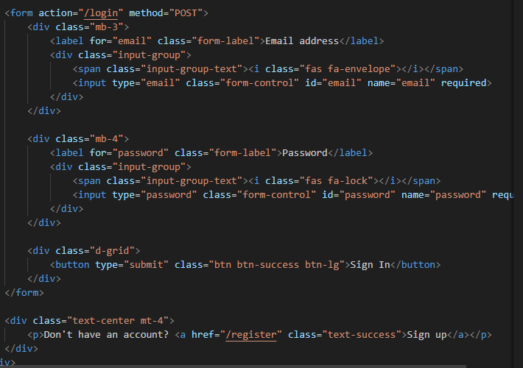

This is what my Database looks like in Version 2

## Database

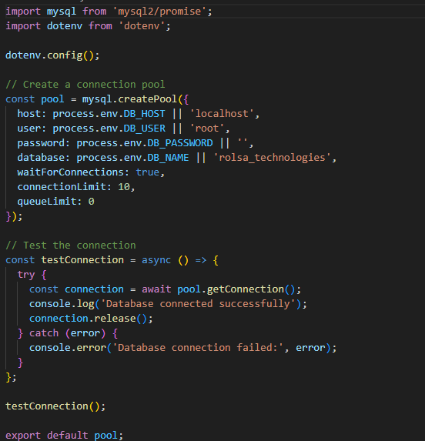

I have made a Database.js in my second version. The new Database.js implementation establishes a secure connection pool to efficiently manage database resources, with built-in connection testing for instant verification. The system now performs an initial health check - when launched, it automatically tests the connection and returns clear status messages ("Connection successful" or "Connection failed") to ensure operational reliability. This proactive approach to connection management provides several key benefits:

1. **Instant Feedback**: Immediate verification during development/deployment
2. **Resource Optimisation**: Connection pooling prevents wasteful reconnections
3. **Fault Visibility**: Clear error messaging for faster troubleshooting
4. **Scalability Ready**: Pool architecture supports growing user loads

# Version 3- 6/04/2025 – 10/04/2025

This is the last and final version of the project. Every element has been reviewed, refined, and perfected—no further changes will be needed after Version 3. Version 3 delivers a polished, production-ready solution with optimal performance, consistency, and reliability.

This is what my Homepage looks like in Version 3

## Homepage



The cookie consent implementation demonstrates compliance with key data protection regulations including GDPR and CCPA, which require explicit user consent for non-essential cookies and tracking technologies. By presenting a clear Accept/Deny option on first visit, the solution achieves three objectives: it fulfils the legal obligations to avoid potential penalties, implements privacy-by-design principles to build user trust through transparency, and maintains a balance between compliance and user experience through technically sound execution. The persistent preference storage and first-visit-only triggering mechanism show an understanding of both regulatory requirements and practical web development considerations, while the unobtrusive design aligns with Rolsa's commitment to ethical yet functional digital experiences. This represents an industry-standard approach to cookie consent management that protects both the business and end-users.

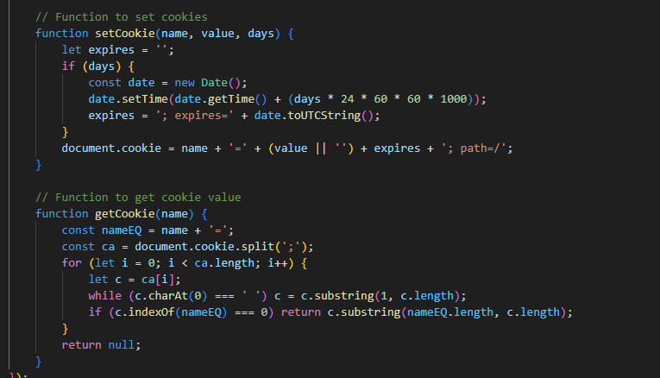

This is what my Footer looks like in Version 3

## Footer



I have added in a Cookie Policy, Privacy Policy and Terms of Use links for the users in case they want to know the legal guidelines and what they are accepting when accepting the cookies. This cookie consent implementation demonstrates best practices in privacy compliance by prominently linking to your Cookie Policy, Privacy Policy, and Terms of Use directly within the banner. These links give users immediate access to critical information about data collection, usage rights, and legal terms before they make their consent decision - a fundamental requirement under modern privacy laws like GDPR and CCPA. The clean, accessible design ensures full transparency while maintaining a frictionless user experience, showing Rolsa's commitment to both legal compliance and ethical data practices. This approach represents the industry standard for obtaining valid, informed consent while building trust with the users.

This is what my Navbar looks like in Version 3

## Navbar



I have changed my navbar by adding in a new logo in for Rolsa technology The redesigned navbar now features an innovative new logo for Rolsa Technologies, marking a strategic brand upgrade that enhances both aesthetics and functionality. This modernised visual identity strengthens the brand recognition with a cleaner, more professional design that immediately communicates Rolsa's commitment to sustainable technology solutions. The logo's optimised sising and placement improve navigation efficiency by serving as a clear, clickable anchor to the homepage while maintaining perfect responsiveness across all devices. By replacing the outdated logo, I have elevated the company's digital presence - the crisp, memorable design not only builds user trust through polished professionalism but also aligns with contemporary web standards for loading speed and accessibility. This thoughtful implementation demonstrates how subtle interface refinements can significantly boost both user experience and brand perception.



This is what my Register looks like in Version 3

## Register

The redesigned sign-up page now features Rolsa's custom logo prominently displayed, replacing the generic account icon to reinforce brand identity throughout the user journey. This visual upgrade is paired with a clear **"**Already have an account? Sign in**"** link that seamlessly redirects to the login page—streamlining the transition between authentication states.



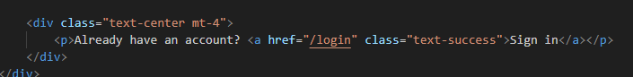

This is what my Log-In looks like in Version 3

## Log-In

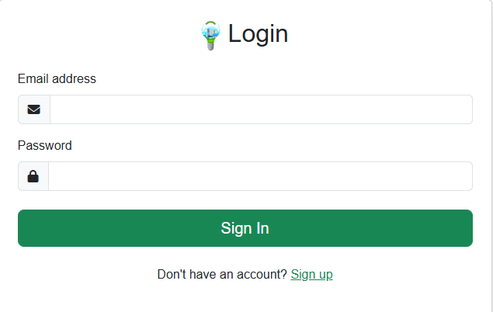

The replacement of the generic arrow icon with Rolsa's custom logo creates a more cohesive brand experience while maintaining intuitive navigation. This subtle but impactful change strengthens visual identity at key interaction points, ensuring users encounter consistent branding throughout their journey. The logo serves dual purposes - it maintains the expected functionality of the original arrow while reinforcing brand recognition. This implementation demonstrates thoughtful attention to detail in merging usability with brand presentation, resulting in a more polished and professional interface that aligns with Rolsa's identity as an innovative technology provider.

This is what my About-Us looks like in Version 3

## About-Us



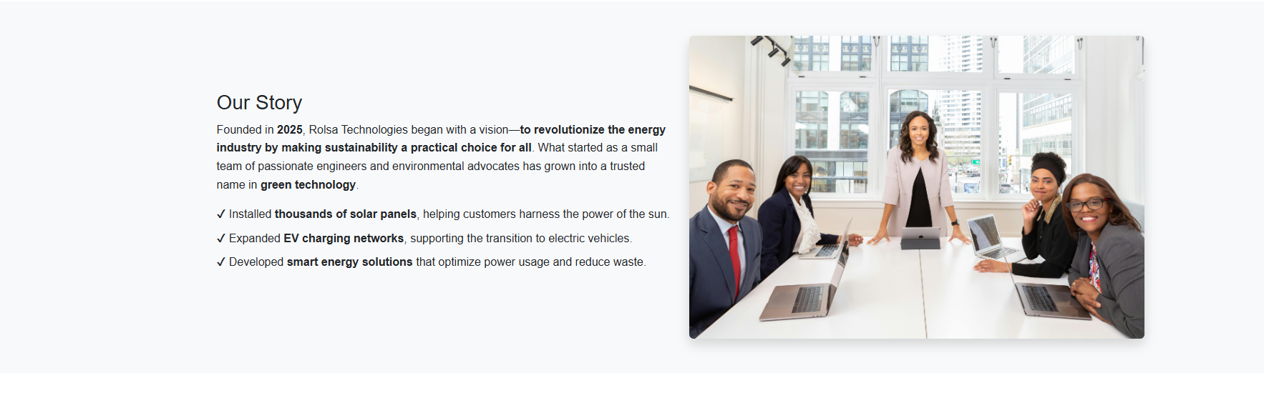

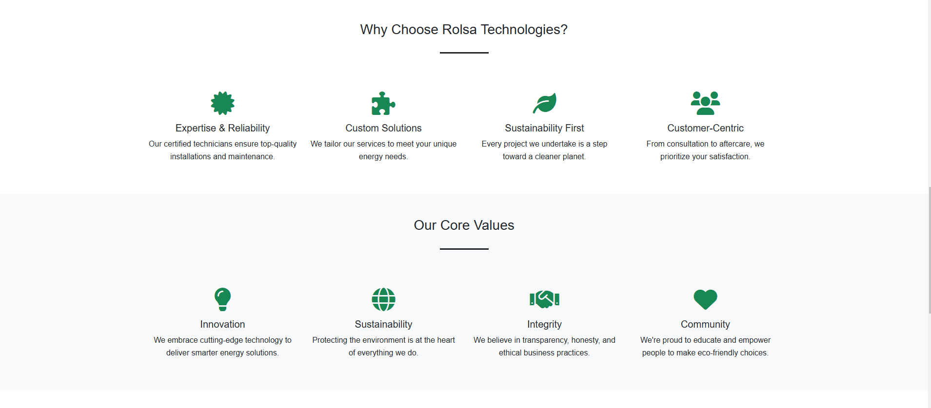

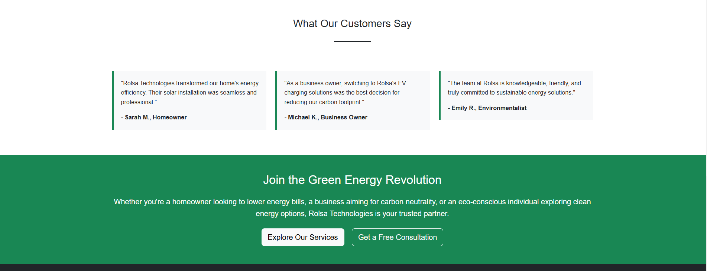

The newly redesigned About Us page for Rolsa Technologies delivers a powerful brand narrative that effectively communicates the company's identity and value proposition. By incorporating detailed sections covering Rolsa's founding story, mission-driven approach, core sustainability values, and measurable impact, the page now serves as both an informative resource and compelling marketing tool. The enriched content establishes credibility through transparent storytelling while strategically highlighting Rolsa's unique differentiators in the green technology sector. Thoughtful formatting with clean visual hierarchy ensures key messages about the company's expertise and achievements are easily digestible, creating an engaging experience that builds trust with potential customers. This transformation elevates the page from a basic company overview to a conversion-focused asset that aligns with Rolsa's professional image and business objectives, ultimately strengthening the brand's digital presence and customer relationships.

This is what my Cookie Page looks like in Version 3

## Cookie Page

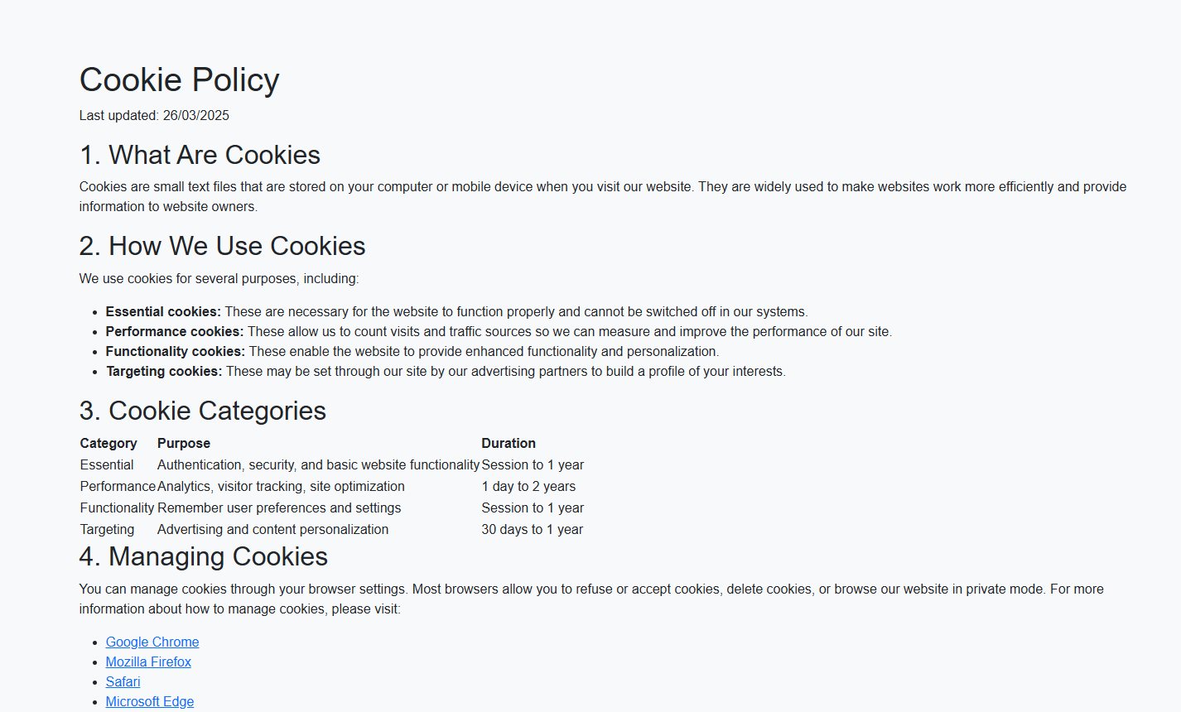

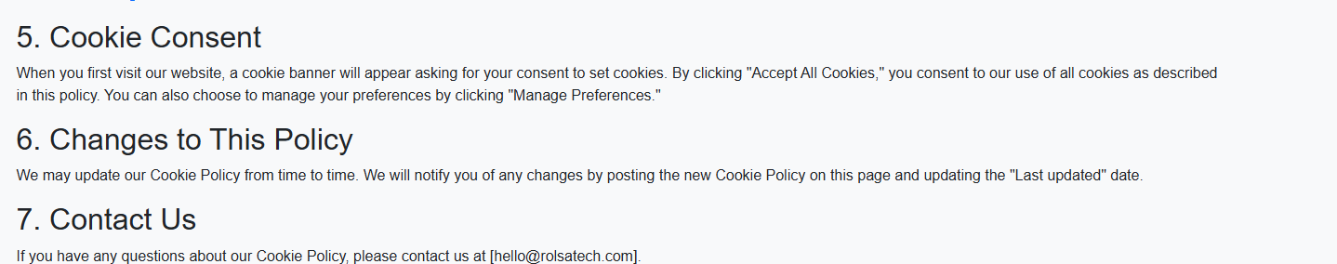

I created a dedicated cookie page to clearly explain what cookies are, how they work, and how our website uses them. This ensures users understand what they’re consenting to while promoting transparency and trust. The page benefits visitors by empowering them with knowledge, and it supports the business by maintaining compliance and fostering a positive user experience. By providing this information upfront, we prioritise clarity and accountability for all parties involved.

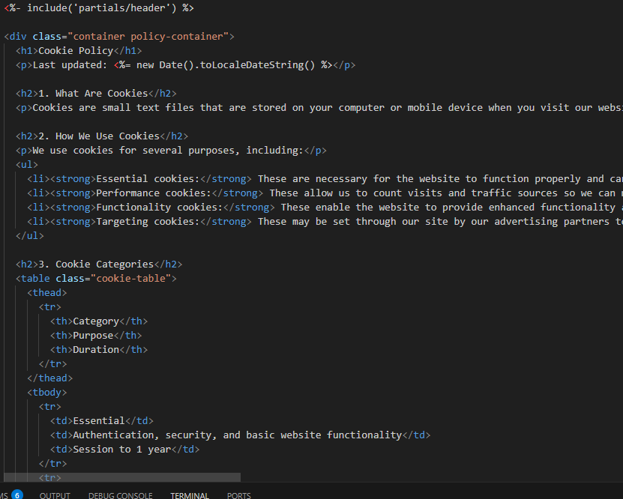

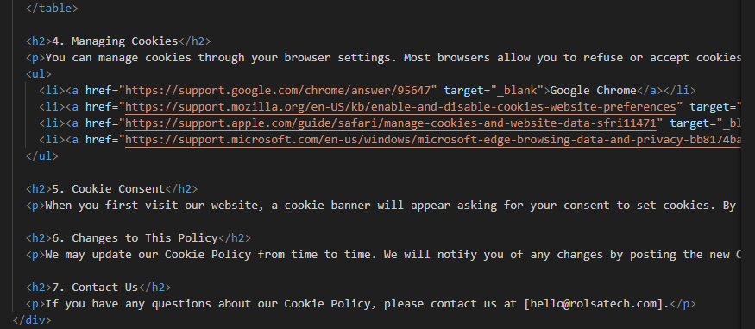

This is what my Privacy-Policy Page looks like in Version 3

## Privacy-Policy Page

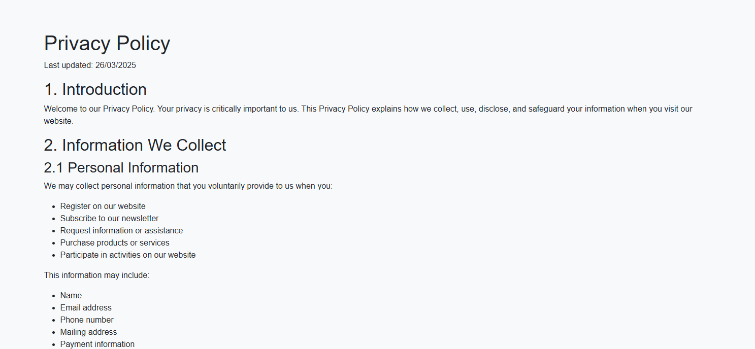

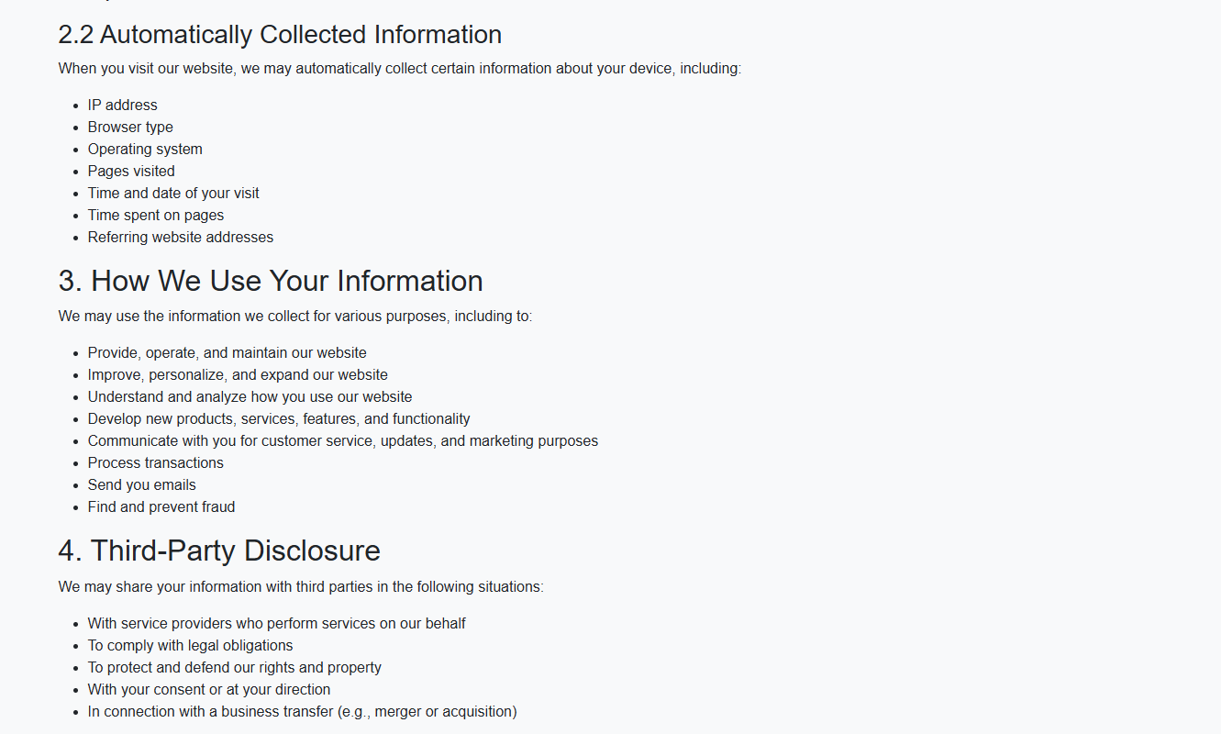

I have created a Privacy Policy page to inform users about the data we collect, how it is used, and any third-party disclosures. This ensures transparency and helps users understand their rights while fostering trust in our business. A clear Privacy Policy not only benefits visitors by keeping them informed but also supports the company by ensuring legal compliance and building credibility. By outlining these practices, we prioritise user privacy and maintain accountability in how personal information is handled

This is what my Carbon Footprint Calculator page looks like in Version 3

## Carbon Footprint Calculator Page

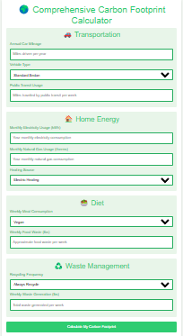

The page now features an improved interface with enhanced CSS styling for better usability and visual appeal. Users can input additional sustainability metrics, including dietary habits and waste management practices, alongside existing data like energy usage and transportation. These expanded questions provide a more comprehensive and accurate carbon footprint calculation. By refining both the design and data collection, we deliver greater value to users—empowering them with detailed insights to make meaningful, eco-friendly lifestyle changes while tracking their environmental impact more precisely.